1.What are the two values of the Boolean data type? How do you write them?

**We can use this data type to represent boolean values. The only allowed values for this data type are:**

**True and False Internally Python represents True as 1 and False as**

**b=True type(b) =>bool**

**True+True==>2 True-False==>1**

2. What are the three different types of Boolean operators?

**AND, OR, and NOT.**

3. Make a list of each Boolean operator's truth tables (i.e. every possible combination of Boolean values for the operator and what it evaluate).

4. What are the values of the following expressions?

(5 > 4) and (3 == 5) – **False i.e. 0**

not (5 > 4)—**True i.e 1**

(5 > 4) or (3 == 5) **-- True i.e 1**

not ((5 > 4) or (3 == 5)) -- **true**

(True and True) and (True == False) – **False i.e. 0**

5. What are the six comparison operators?

**Less than ( < )**

**Less than or equal to (<=)**

**Greater than (>)**

**Greater than or equal to (>=)**

**Equal to ( == )**

**Not equal to ( != )**

6. How do you tell the difference between the equal to and assignment operators?Describe a condition and when you would use one.

**Equal operator is used to check the condition and is denoted by ‘==’**

**Assignment is denoted by ‘=’ and a value is assigned to the variable or identifier**

7. Identify the three blocks in this code:

spam = 0

if spam == 10:

print('eggs')

if spam > 5:

print('bacon')

else:

print('ham')

print('spam')

print('spam')

**OUTPUT-**

**ham**

**spam**

**spam**

8. Write code that prints Hello if 1 is stored in spam, prints Howdy if 2 is stored in spam, and prints Greetings! if anything else is stored in spam.

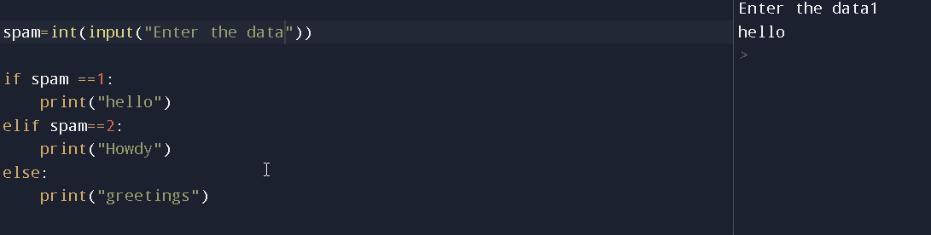

9.If your programme is stuck in an endless loop, what keys you’ll press?

**Win+c**

10. How can you tell the difference between break and continue?

**Break – it breaks the loop on the condition given**

**Continue – jumps to next iteration in the loop , does not break out of the loop**

11. In a for loop, what is the difference between range(10), range(0, 10), and range(0, 10, 1)?

**range(10)- consist of 0 to 9 including 9 and excluding 10**

**range(0,10)- same as above**

**range(0,10,1)- step 1 for the number from zero to 10 which is by default , and the output will be same as above conditions**

12. Write a short program that prints the numbers 1 to 10 using a for loop. Then write an equivalent program that prints the numbers 1 to 10 using a while loop.

## For loop

for I in range(0,10):

print(i)

## While loop

i=0

while i<10:

print(i)

i=i+1

13. If you had a function named bacon() inside a module named spam, how would you call it after importing spam?

**spam.bacon()**